How to DECLARE or COMMIT your child to a swim meet
First log-in to the website (www.novatoriptide.org). Select the meet you are committing your swimmer to:
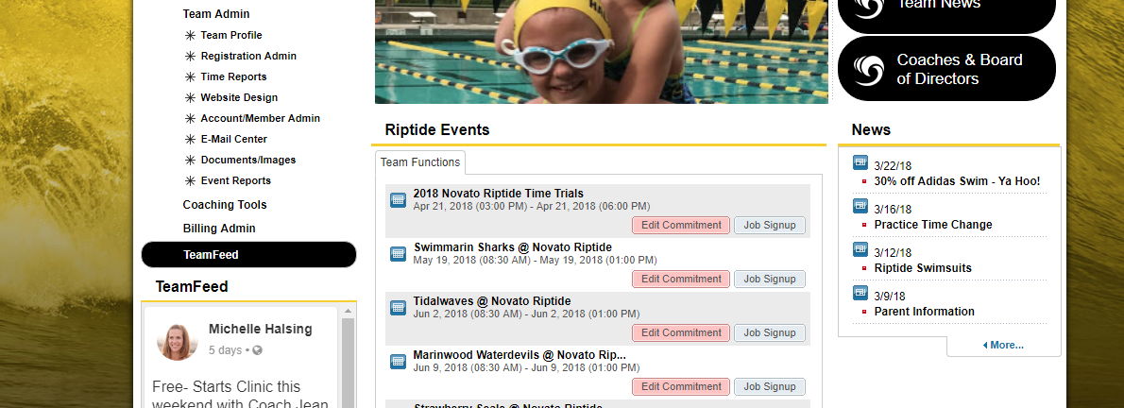
Click on the Commitment Button
You should then see this page. It will contain information about the meet. Please read the information.
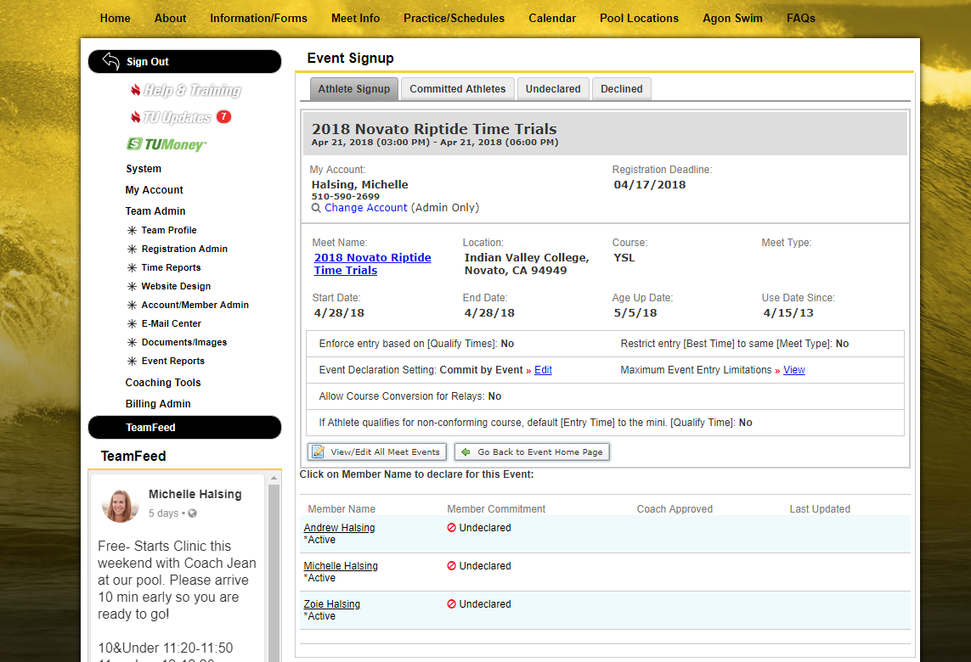
Find your swimmer(s) name:
Click on your swimmer. You should find yourself on another page with the meet listed at the top and your swimmers name listed below. You will see a box labeled “Declaration”.
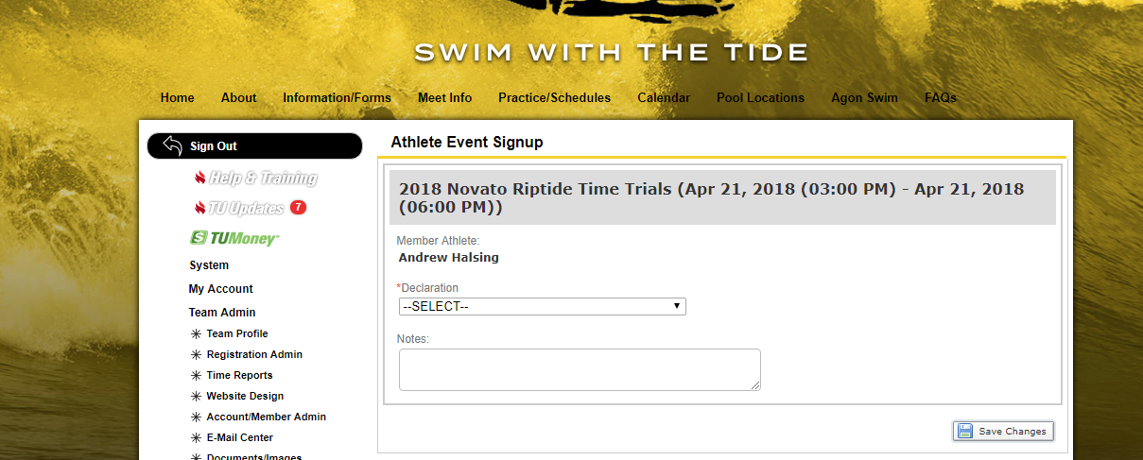
Click on the drop down and select “Yes,please sign [name} up for this event” or “No, thanks, [name] will NOT attend this event”. We ask that you declare yes or no for every meet.
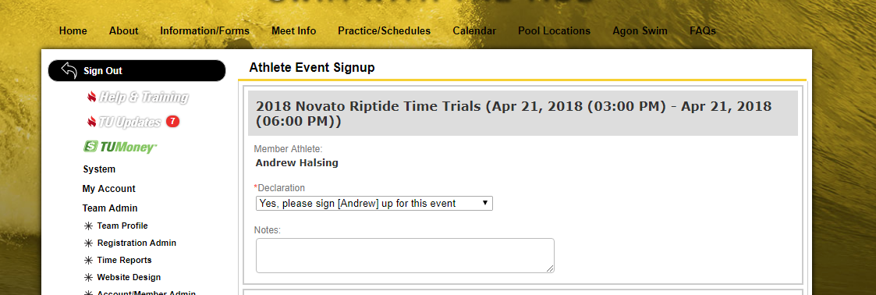
No below the declaration area is a lot of “stuff” do not select anything else other than the “SAVE CHANGES” button. The other area is for the coaches and they will assign then to the strokes they will swim for the meets. If you would like to swim a specific stroke (that is not free or back) tell your coaches.
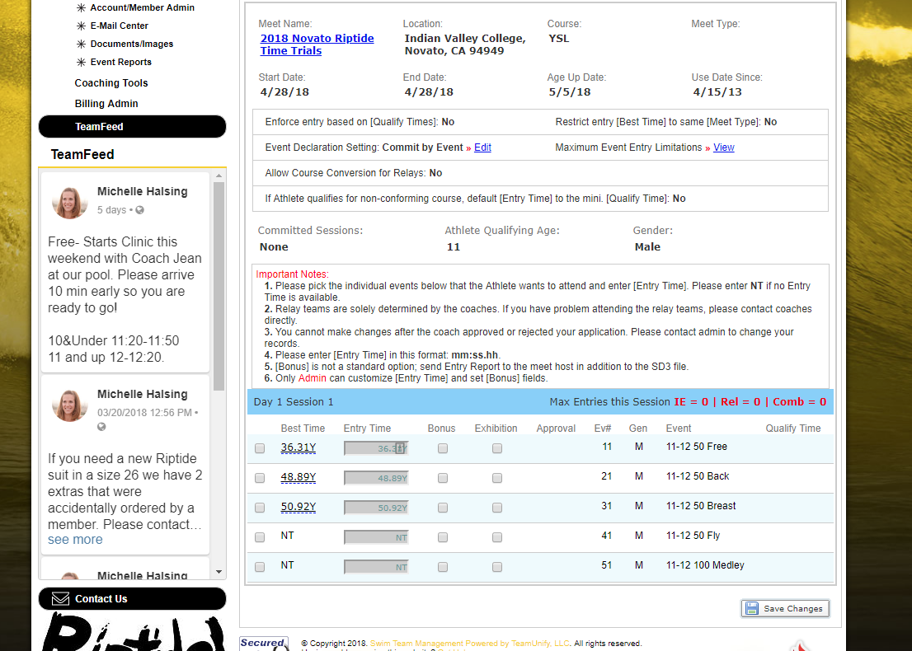
After you hit save it should look like this:
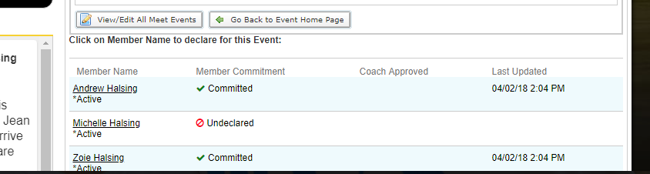
A green arrow and the word committed should be next to your swimmer. Once you get here your child has been entered into the meet. If you decline the meet it will say that instead.

